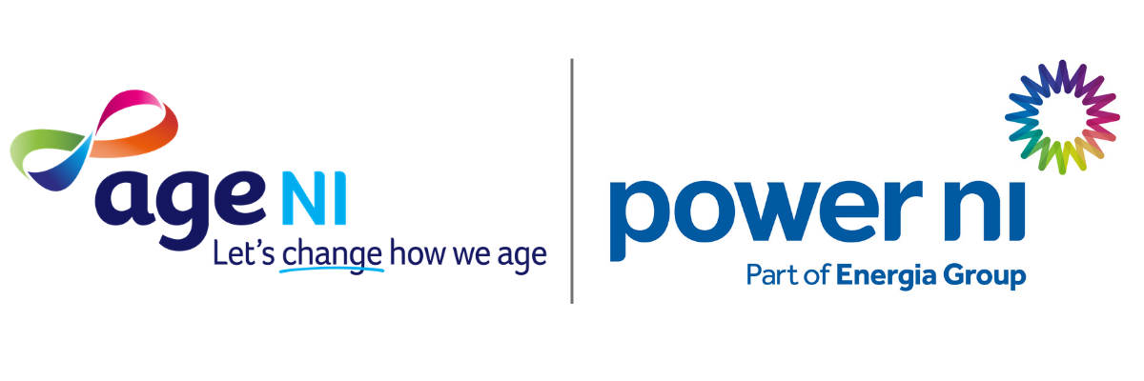

Electricity Customer Survey
Age NI in partnership with Power NI are seeking to gain insights into older people in Northern Ireland’s experience of electricity costs, supplier communication, digital access and support needs. The findings will help Age NI to identify advice, advocacy, and service development priorities, while helping Power NI understand how supplier support and communications can better meet the needs of its older customers.

- Age Band
- 50-60
- 61-70
- 71-80
- 81-90
- 91+
- Prefer not to say
- Including yourself, how many people live in your household?
- 1
- 2
- 3
- 4
- 5+

- How easy do you find it to understand your electricity bills, tariffs, and charges?
- Very easy
- Fairly Easy
- Difficult
- Very difficult
- Have you experienced difficulty in paying your electricity bills in the last 12 months?
- Yes
- No
- How confident do you feel about knowing where to get help if you are worried about paying your electricity bill?

- Very confident
- Fairly confident
- Not very confident
- Not confident at all
- Have you contacted your electricity supplier in the last 12 months about energy costs or payment difficulties?

- Yes
- No

7. If you answer yes to Q6 above: what support was offered? (Select any that apply)
- Affordable payment plan
- More time to pay
- Change to payment method
- Help with keypad/prepayment top-ups
- Benefit entitlement check
- Electricity-saving advice
- Referral to debt, money, or grants advice
- Customer Care Register / additional needs support
- Support for power cuts or medical equipment needs
- Trusted contact or nominated person added to account
- Follow-up call or ongoing check-in
- No support offered
- Other
- Can’t remember
8. If you checked any boxes in Q7 above, was the support helpful?
- Very helpful
- Somewhat helpful
- Not helpful
- Prefer not to say
- I did not contact my electricity supplier

9. If you needed help with your electricity account, how would you prefer to contact your supplier?
- Telephone
- In person
- Email
- Website
- Family member/carer assists me
- Other
10. How would you prefer to receive information back from your electricity supplier?
- Telephone
- Letter
- Letter in large print
- Email
- Text message
- Trusted family member/carer
- Community organisation
11. Do you use any of the following to manage household bills?
- Online account
- Mobile app
- Email
- None of these
12. If you answered: "none of these" to Q11, please indicate why?
- No internet
- Low confidence / low skills using internet or online services
- Preference for paper/phone communication
- Someone else manages it
- Other (please specify in text box below)
13. Does anyone help you manage your electricity account or household bills?
- No
- Family member
- Friend
- Carer / Support Worker
- Other
14. Before today, were you aware that electricity suppliers may offer support for customers experiencing financial difficulty or vulnerability?

- Yes
- No
- Not sure
15. Are you aware that every electricity supplier has a Customer Care Register, where customers can share if they have any additional needs or any information that may make it easier for them to be served as a customer? Examples: doorstep password scheme, special bill formats (Braille / large print).

- Yes
- No
- Not sure

16. If you answered Yes to Q15 overleaf, do you know if you are registered on a Customer Care Register with your electricity supplier?

- Yes
- No
- Not sure

17. What would help you most to manage your home electricity costs? (Select up to three)
- Help contacting supplier
- Electricity efficiency improvements
- Better information and advice
- Help checking entitlement to benefits/grants
- Emergency financial support (if in receipt of benefits/government assistance)
- Easier payment options
- Regular supplier check-ins
- Other (please specify in text box below)
18. Have you received information from your electricity supplier about support available for customers struggling with electricity costs?
- Yes
- No
- Can't remember
19. If you answered yes to Q18 above, did you understand the information?
- Yes
- No
20. Again, re Q18 above, did you act upon the information?
- Yes
- No

21. If you were struggling to pay your electricity bills, how comfortable would you feel contacting your supplier for support?
- Very comfortable
- Comfortable
- Neither comfortable nor uncomfortable
- Uncomfortable
- Very uncomfortable
22. If you answered "uncomfortable" or "very uncomfortable" to Q21 above: What would make contacting the supplier easier?
- A clear phone number for people who need help
- Speaking to a real person rather than using an automated system
- Reassurance that asking for help would not make things worse
- Being able to have a family member, friend, carer or support worker speak on my behalf
- Help from Age NI or another trusted organisation to contact the supplier

END OF SURVEY

If completing and returning the survey to Age NI by post, please address it to:
Age NI Office
31 Ulsterville Avenue
Belfast
BT9 7AS

